**GOLD STAR HIGH SCHOOL GANGU**

**Name ………………………………………………………….**

**END OF YEAR ASSESSMENT 2023**

**AGRICULTURE S.3**

**2 hours**

**Answer all questions**

**PART A**

1. Soil is a mixture of various components. If well maintained, these components can support crop growth very well. However, the farmers in Gayaza are always complaining about the soils being poor. Most of them are maize growers and the yields have been continuously low.

What soil improvement practices would you advise these farmers to use in their maize gardens? (8 scores)

………………………………………………………………………………………………… ………………………………………………………………………………………………… ………………………………………………………………………………………………… ………………………………………………………………………………………………… ………………………………………………………………………………………………… ………………………………………………………………………………………………… ………………………………………………………………………………………………… ………………………………………………………………………………………………… ………………………………………………………………………………………………… ………………………………………………………………………………………………… ………………………………………………………………………………………………… ………………………………………………………………………………………………… ………………………………………………………………………………………………… ………………………………………………………………………………………………… ………………………………………………………………………………………………… …………………………………………………………………………………………………

…………………………………………………………………………………………………

1. The government of Uganda is giving people support through the PARISH

DEVELOPMENT MODEL. Many of these Ugandans wish to rear animals and each individual one has a different choice of animal in mind. What considerations should such people make when choosing an animal to rear? (8 scores) ………………………………………………………………………………………………… ………………………………………………………………………………………………… ………………………………………………………………………………………………… ………………………………………………………………………………………………… ………………………………………………………………………………………………… ………………………………………………………………………………………………… ………………………………………………………………………………………………… ………………………………………………………………………………………………… ………………………………………………………………………………………………… ………………………………………………………………………………………………… ………………………………………………………………………………………………… ………………………………………………………………………………………………… ………………………………………………………………………………………………… ………………………………………………………………………………………………… …………………………………………………………………………………………………

…………………………………………………………………………………………………..

1. At Gayaza High School farm, records are kept. Below is an example of the farm records kept

**Name: ………………………………………………………… Breed: ………………………**

**Age: ……………………… Sex: ………………………… Weight: ……………………………………………..**

**Date: ……………………………………………………………………………………………………………………**

**Complaint:**

**……………………………………………………………………………………………………………………………………………**

**…………………………………………………………………………………………………………………………………………… ……………………………………………………………………………………………………………………………………………**

**Diagnosis:**

**…………………………………………………………………………………………………………………………………………… ……………………………………………………………………………………………………………………………………………**

**Treatment given:**

**……………………………………………………………………………………………………………………………………………**

**…………………………………………………………………………………………………………………………………………… …………………………………………………………………………………………………………………………………………..**

**Comment:**

**…………………………………………………………………………………………………………………………………………… …………………………………………………………………………………………………………………………………………..**

(a) From this example, how would you describe a farm record? (2 scores)

………………………………………………………………………………………………… ………………………………………………………………………………………………… …………………………………………………………………………………………………

…………………………………………………………………………………………………

(b). Which kind of information can you read from this record? (2 scores)

………………………………………………………………………………………………… ………………………………………………………………………………………………… ………………………………………………………………………………………………… …………………………………………………………………………………………………

………………………………………………………………………………………………… ………………………………………………………………………………………………… ………………………………………………………………………………………………… ……………………………………………………………………………………………….

(c). If you were a dairy farmer, of what importance would this farm record be to you?

(4 scores)

……..……………………………………………………………………………………………

………………………………………………………………………………………………… ………………………………………………………………………………………………… ………………………………………………………………………………………………… ………………………………………………………………………………………………… ………………………………………………………………………………………………… ………………………………………………………………………………………………… ………………………………………………………………………………………………… ………………………………………………………………………………………………… ………………………………………………………………………………………………… ………………………………………………………………………………………………… …………………………………………………………………………………………………

……………………………………………………………………………………………….....

.....................................................................................................................................

4. The farmers in Uganda mainly use simple tools in their gardens. After use, they leave them outside, it rains on them and they get rusty. Some farmers misuse the tools for wrong activities. These tools get blunt or break. As a result, the farmers complain that the tools cannot do good work.

What advice can you give these farmers so that they benefit from the use of their tools (6 scores)

………………………………………………………………………………………………… ………………………………………………………………………………………………… ………………………………………………………………………………………………… …………………………………………………………………………………………………

…………………………………………………………………………………………………

………………………………………………………………………………………………… ………………………………………………………………………………………………… ………………………………………………………………………………………………… ………………………………………………………………………………………………… ………………………………………………………………………………………………… ………………………………………………………………………………………………… ………………………………………………………………………………………………… ………………………………………………………………………………………………… ………………………………………………………………………………………………… ………………………………………………………………………………………………… ………………………………………………………………………………………………… ………………………………………………………………………………………………… ………………………………………………………………………………………………… …………………………………………………………………………………………………

………………………………………………………………………………………………….

5) Farm animals are selected for breeding basing on different factors.

As a student of S.3 agriculture, explain different systems of selecting farm animals for breeding (06mrks)

b) how is the selection of farm animals important to a farmer (04marks)

**PART B (Answer on a separate answer sheet)**

**6)** The digestive system is a group of organs that work together breakdown complex food materials into simple soluble substances that can be absorbed into the blood stream.

Different species of domestic animals are better suited to digest certain types of food or feeds better than others.

1. As a student of S.3 who learnt about digestion in ruminants, with the help illustration, show how digestion in a goat is different from that of an avian (10mrks)

7) The people of KIGANGAZZI have been keeping poultry for many generations. Most of their birds have to look for food in the fields including the neighbours’ fields. When disease strikes, all the poultry in the community get affected. The birds have three laying seasons in a year and in each season they lay 15 eggs on the average. The off layers are put on top of a bus and taken to be sold in far off cities.

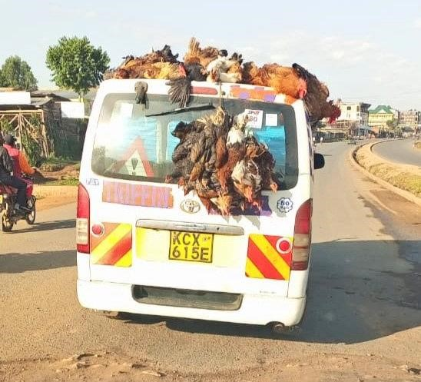

Task: Prepare a message you would use in a community meeting to help these farmers benefit more from poultry

END.